***2025 New Zealand Geothermal Association (NZGA)***

***Future Energy and Innovation Leaders Sponsorship***

Are you a young professional or tertiary level student passionate about the energy transition and the role of geothermal resources in Aotearoa New Zealand? The New Zealand Geothermal Association (NZGA) is excited to offer sponsorship opportunities **for up to twenty (20) students** to attend the 2025 NZGA seminar and New Zealand Geothermal Week events in Taupō between Monday 28 July to Saturday 2 August 2025. With a theme focused on "***Geothermal: New Zealand’s Global Opportunity***", this annual seminar aims to bring together industry leaders, policymakers, academia, and the geothermal community to address the importance of geothermal resources for both national and international energy policies.

As a sponsored Future Energy & Innovation Leader, you will have the chance to engage with industry professionals, senior leaders, and diverse stakeholders, enhancing your leadership skills and sharing your learnings with attendees. Our thanks to Ara Ake and MTL, as due to their generous support NZGA is able to provide this opportunity.

Each sponsorship package includes coverage for:

* Travel and/or accommodation costs (up to $350 incl GST).
* Monday 28 July: Tour of Whakarewarewa village.
* Monday 28 July: Industry-led presentation hosted by GNS Science.
* Monday 28 July: Industry networking event hosted by MB Century.
* Tuesday 29 July: Panel discussion with a global geothermal focus.
* Tuesday 29 July: Panel discussion focussing on carbon capture and utilisation.
* Tuesday 29 July: Industry-led presentation hosted by Mercury.
* Tuesday 29 July: Industry networking event hosted by Women in Geothermal NZ.
* Wednesday 30 July: NZGA Winter Seminar (full day).
* Wednesday 30 July NZGA Winter Seminar dinner.
* Thursday 31 July: Regional field trips.
* Thursday 31 July: Bowling & Beers networking event.

**The total sponsorship value amounts to over $900**

By participating in this sponsorship, you gain access to valuable knowledge exchange opportunities, expand your professional network, and even get the chance to be introduced at the NZGA seminar.

To apply for this incredible opportunity, simply complete the application form provided below and email it to [committee@nzgeothermal.org.nz](mailto:committee@nzgeothermal.org.nz). The application deadline is **Monday, 5 May 2025.** Successful applicants will be notified by Friday 16 May 2025.

Join us at the forefront of the energy transition and let your voice be heard. Be part of the 2025 NZGA seminar and New Zealand Geothermal Week to shape the future of geothermal energy in Aotearoa New Zealand. Apply today!

Terms and conditions:

* Previous recipients of New Zealand Geothermal Week scholarships sponsored by NZGA are not eligible to apply.
* Applicants must be at least 18 years of age and must either be a tertiary student or no more than 10 years into employment at the time of 2025 New Zealand Geothermal Week (28 July - 2 August 2025).
* For young professionals: a maximum of **one** applicant per organisation is eligible for this sponsorship.
* For students: a maximum of **five** applicants per tertiary institute are eligible for this sponsorship

**\*\*Application Form on next page\*\***

**2025 New Zealand Geothermal Association (NZGA) Future Energy and Innovation Leader Sponsorship**

**Application form**

The application deadline is **Monday 5 May 2025**. Successful applicants will be notified by Friday 16 May, 2025.

**Tell us about yourself: Future Energy & Innovation Leader details**

| Name | |
| --- | --- |
| First name: | Surname: |
| Contact details | |
| Email address: |  |
| Contact phone number: |  |
| Current employer (if applicable): |  |
| *Please only complete this section* ***if******you are a student****:* | |
| Name of education provider: | |
| Course of study |  |
| Year commenced study |  |
| Expected year of completion |  |

**Please confirm that:**

**I am 18 years of age or older.**

**I have no more than 10 years of employment at the time of the 2025 New Zealand Geothermal Week (28 July - 2nd August 2025).** 

**Tell us about your motivation:**

**Please explain in no more than 300 words of your interest in attending the 2025 New Zealand Geothermal Week:**

**Please explain in no more than 300 words how you will benefit from attendance and participation at the 2025 New Zealand Geothermal Week activities:**

**Please provide the name and contact details of your manager (or supervisor from your educational provider).**

| Name | |
| --- | --- |
| First name: Surname: | |
| Contact details | |
| Email |  |
| Contact phone number |  |
| Position: | |
|  | |
| To be completed by manager / supervisor:  Reasons why you would support the applicant: (max 100 words) | |
|  | |

**Note for successful applicants:**

***Please note the following:***

1. **Travel and Accommodation Sponsorship**: The maximum sponsorship value for travel and/or accommodation is $350, including GST. To facilitate the reimbursement process, please ensure that you provide us with confirmation documents or receipts for your travel and accommodation expenses. This will enable us to process your sponsorship payment efficiently.

2. **Attendance**: We understand that in some cases it might not be possible to attend all of the events provided by your scholarship. Many of these events have limited capacity, and therefore, if you foresee being unable to attend any events, please advise NZGA of any events you might miss.

We appreciate your cooperation in adhering to these requirements. Should you have any questions or need further assistance, please do not hesitate to reach out to us. We look forward to your participation in the seminar and supporting your journey in the geothermal sector.

___________________________________ ______________

Applicant’s signature DD/MM/YYYY

Table 1: Preliminary 2025 New Zealand Geothermal Week programme.

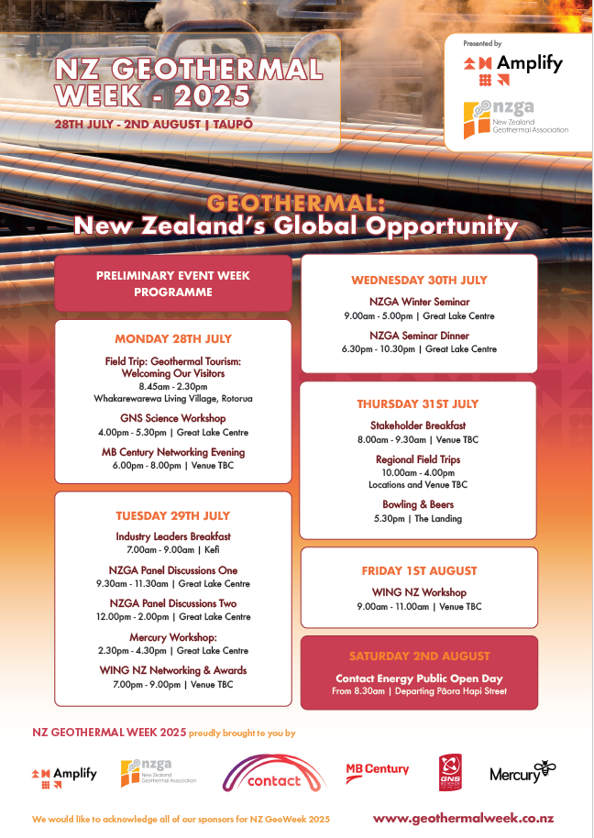

Further event details will be posted on the [New Zealand Geothermal Week 2025 website](https://www.taupo.biz/nzgeothermalweek).