Instructions for Chuck Landis written tributes (GSNZ Misc. Pub. 15x)

- Microsoft Word 2007 or later needed.
- These instructions have been written based on Word 365 (2020).
- Intended layout is for two columns of text per page.
- To format the text, please use the Styles (e.g., Normal for body text, Heading 1, 2, etc. as appropriate for the heading level required) available under the Home tab in the top ribbon.
- Do not format the text manually using the bold, italics, etc. buttons or changing the font or font size.
- To insert an image, place the text cursor (the flashing bar) in the position where you would like the image, click the Insert tab and then the Pictures button. From within the Insert Picture window that appears, navigate to the desired image, click to select it, then click the Insert button. By default, Wrap Text is set to “In Line with text”, please do not change this.
- To add a caption to an image, right-click on the image, then Insert Caption. After typing the caption, click OK.
- Additionally, all images must also be supplied separately in a common format (e.g., .jpeg)
- See next page for examples on how images and text should appear.

Tribute title/Heading 1 style

Body text (Normal style)
Body text (Emphasis style)

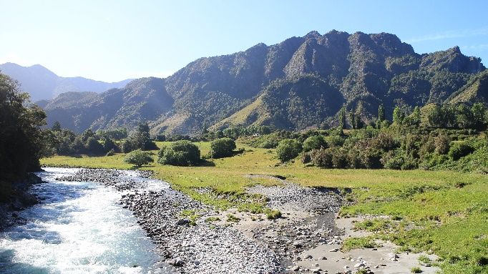
Figure 1. Matakitaki River, view to E from Horse Terrace bridge.

Heading 2
Body text (Normal style)
Body text (Emphasis style)

Figure 2. Matakitaki River, view to E from Horse Terrace bridge.

Heading 3
Body text (Normal style)
Body text (Emphasis style)

Figure 3. Matakitaki River, view to E from Horse Terrace bridge.

Heading 4
Body text (Normal style)
Body text (Emphasis style)

Figure 4. Matakitaki River, view to E from Horse Terrace bridge.

